**Phase End Project**

**ASP.NET MVC Ecommerce Site to Sell Laptops**

**Aim:**

To Create an ASP.NET MVC web application to sell laptops online.

**Github link:**

[**https://github.com/Sukirthalakshmanan1/MVC_laptop**](https://github.com/Sukirthalakshmanan1/MVC_laptop)

**Procedure:**

* Create an ASP.NET Web application =>MVC application
* Create three class Library BAL(Business Access Logic layer),DAL,Helper classes.
* BAL class has the properties of the class and their validations
* DAL class has the logic to access the data from the database and to perform operations.
* Helper class is used as an extra layer over DAL to hide the details of the logic.
* Add Business Reference to DAL and Helper.
* Add DAL reference to Helper.
* Add Helper reference to MVC Application.
* Build the solution and set the dependencies.
* MVC depends on BAL and Helper
* Data Acccess Library depends on BLL.
* Helper depends on BLL and DAL.
* In Web config add the connection string to the database
* Create a model classes.
* Create a controller class to Register,login,Forget password,payment,Laptop sale.
* Perform Add to cart ,Show my cart operations.
* From the cart delete the laptop product which is not needed and Buy operation to buy the product.
* Create a controller class
* Create views for adding the item to cart,to display the cart,deleting item from cart, details of items from the cart and to buy the item.
* And run all

**Output:**

**Home Page:**

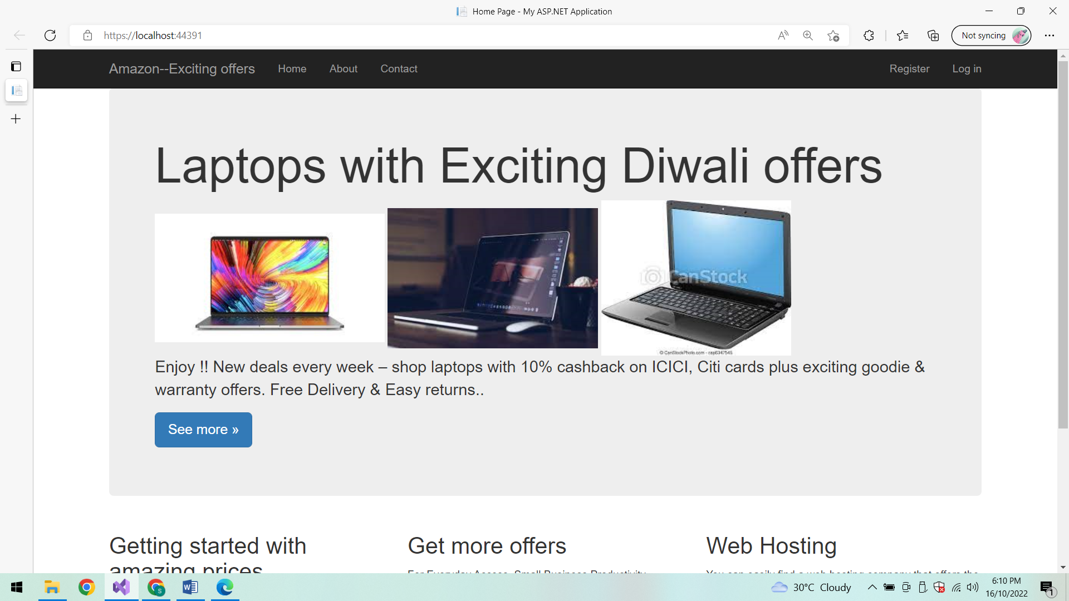

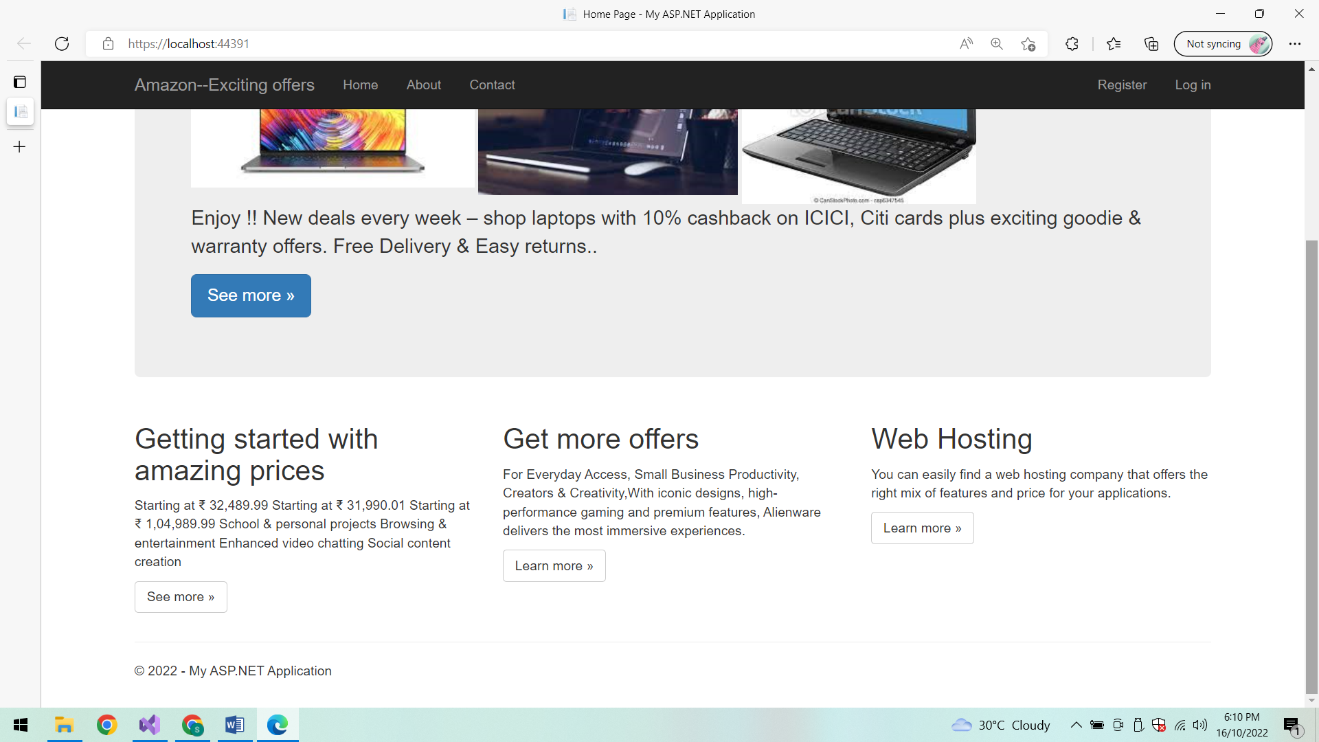

**Register:**

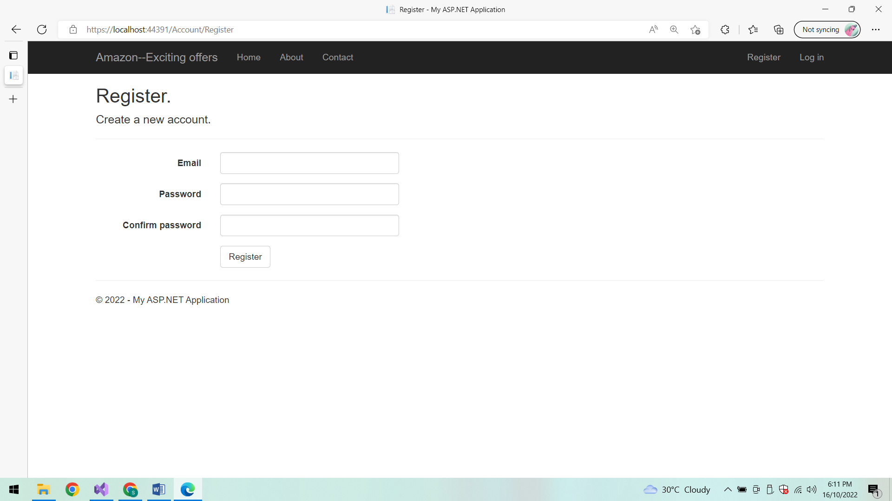

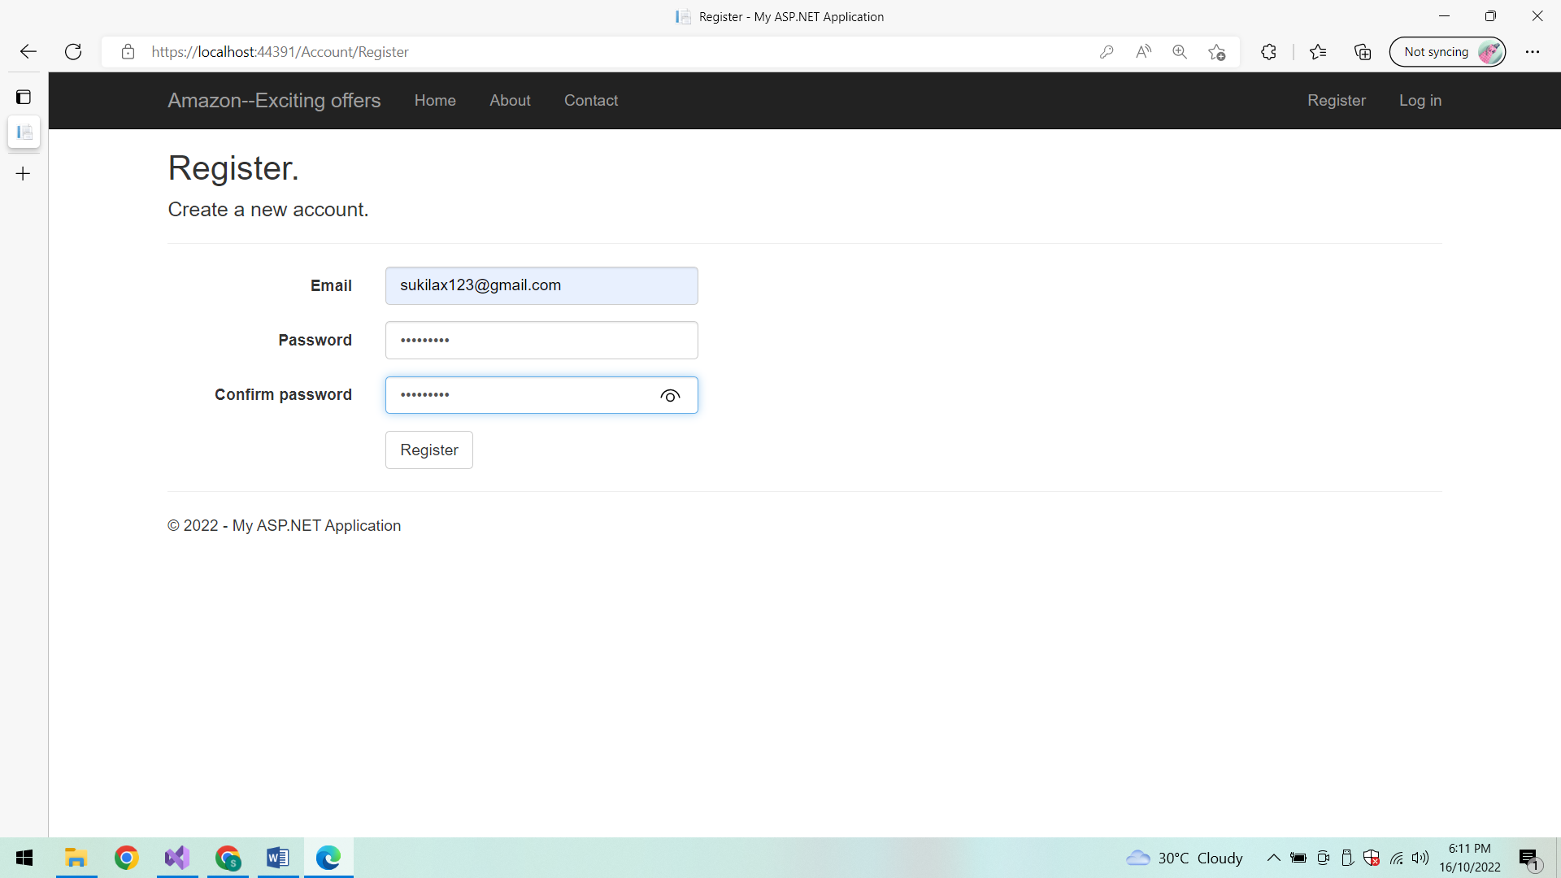

**After Successful Login:**

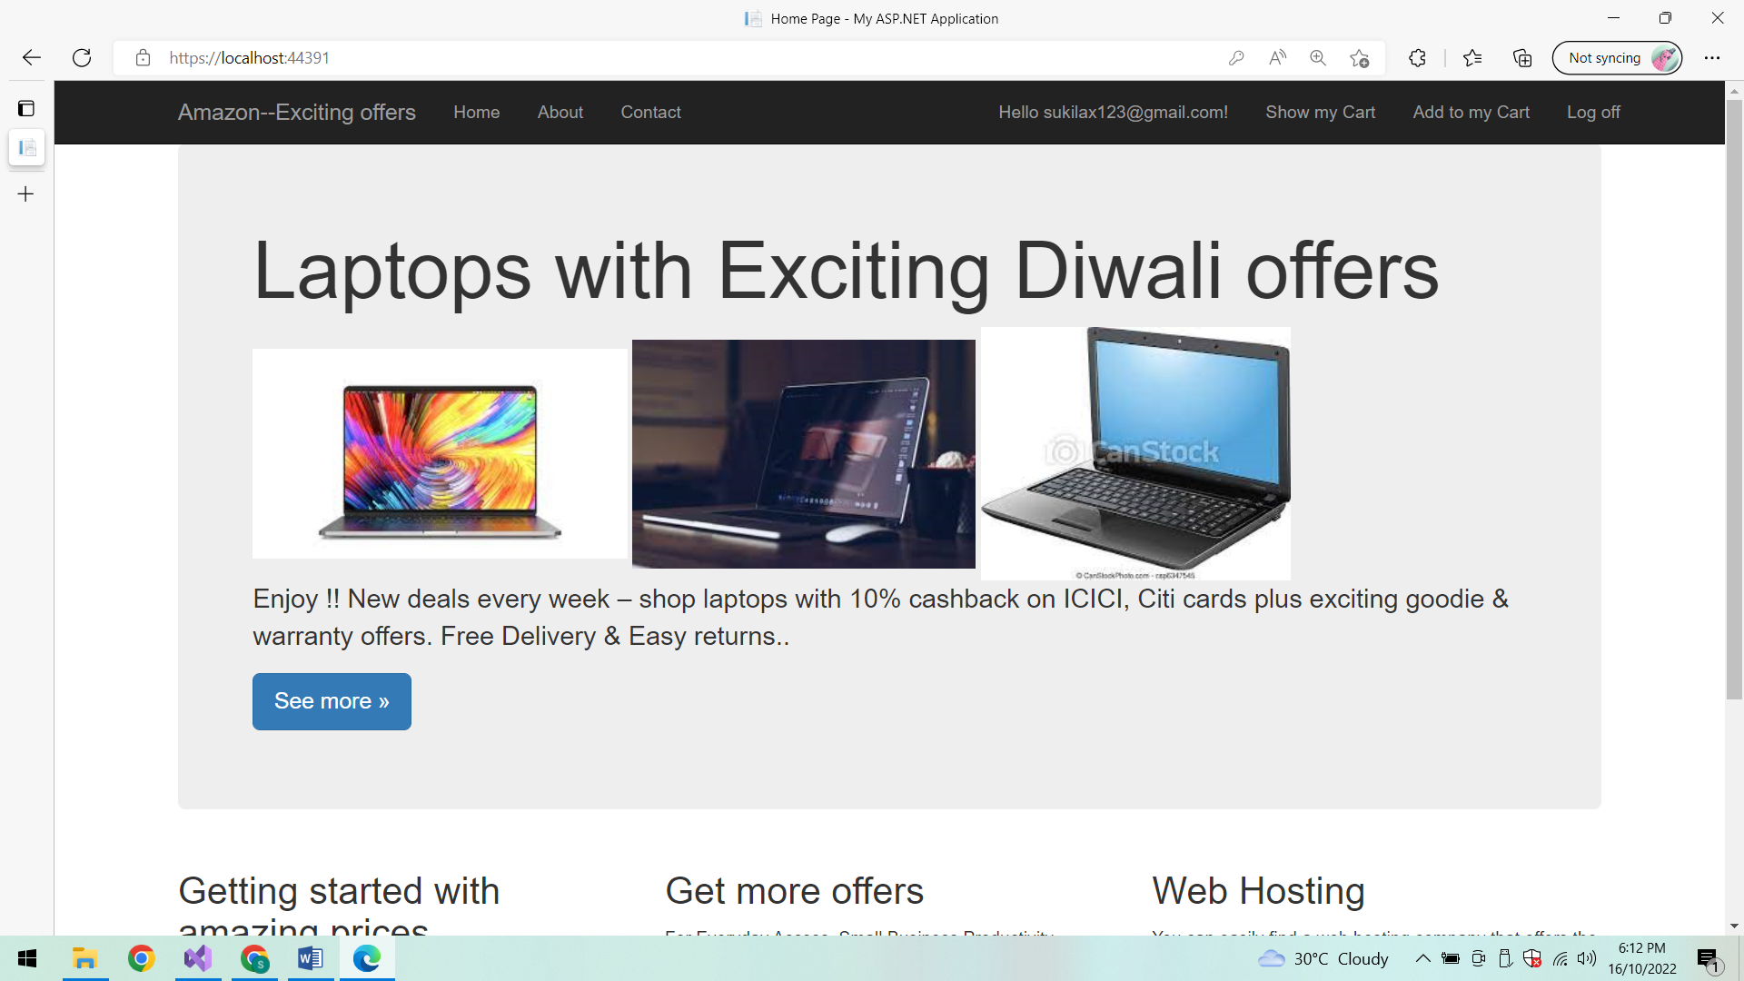

**Show My cart:**

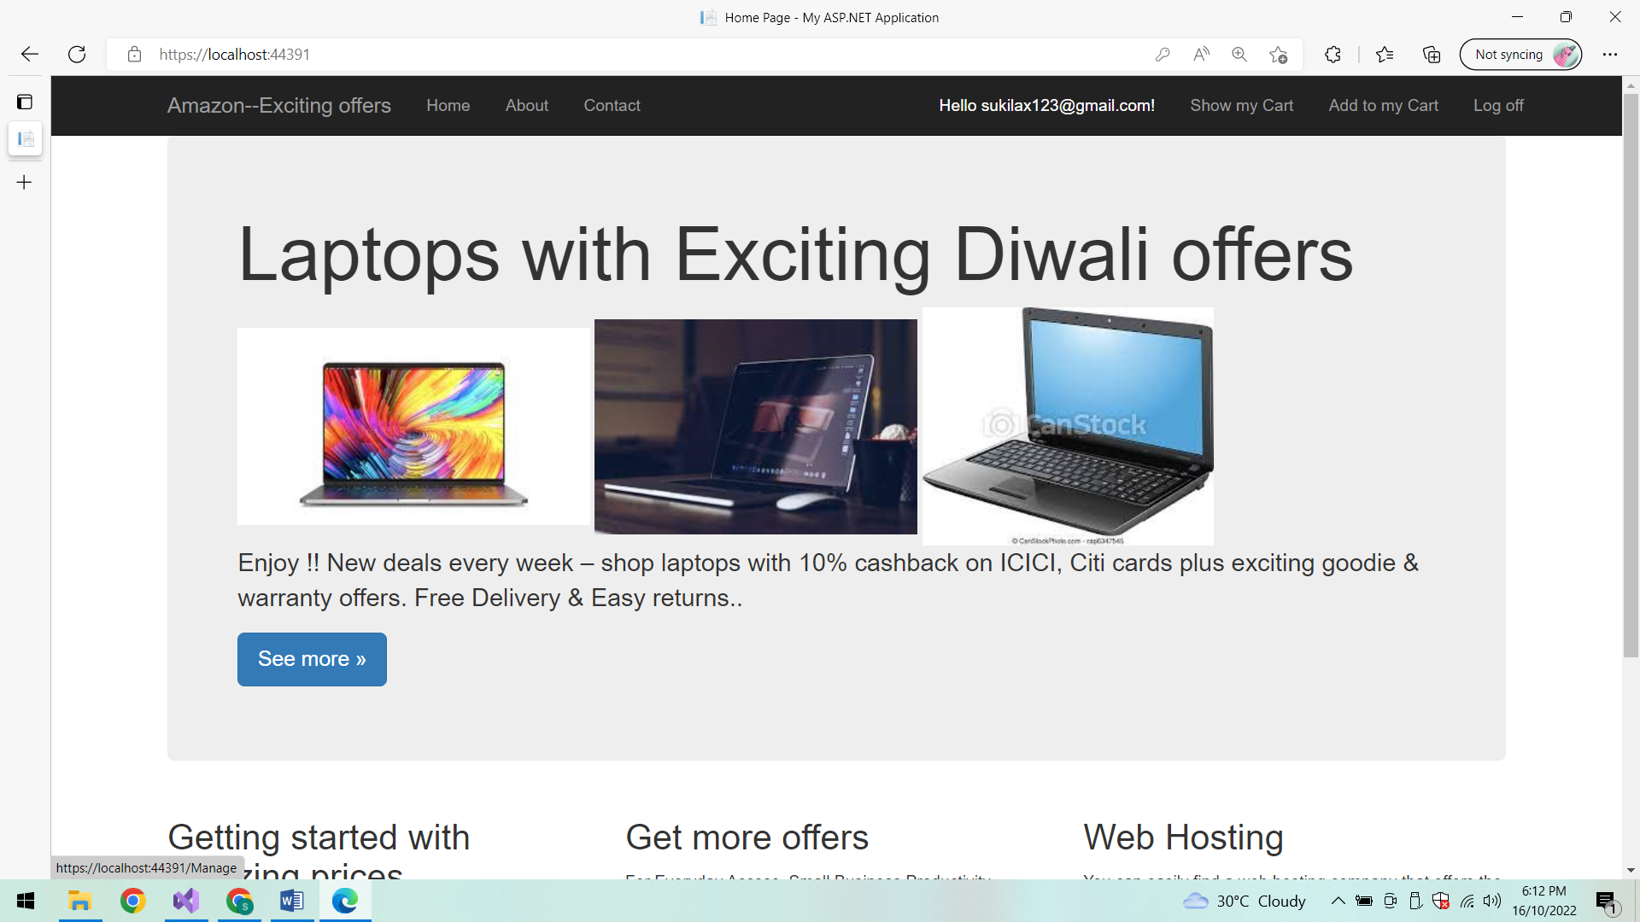

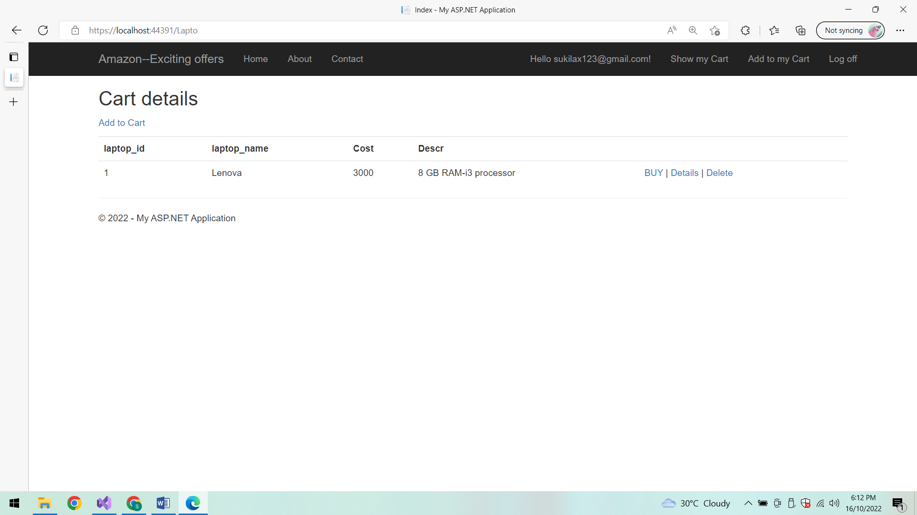

**Add to My cart:**

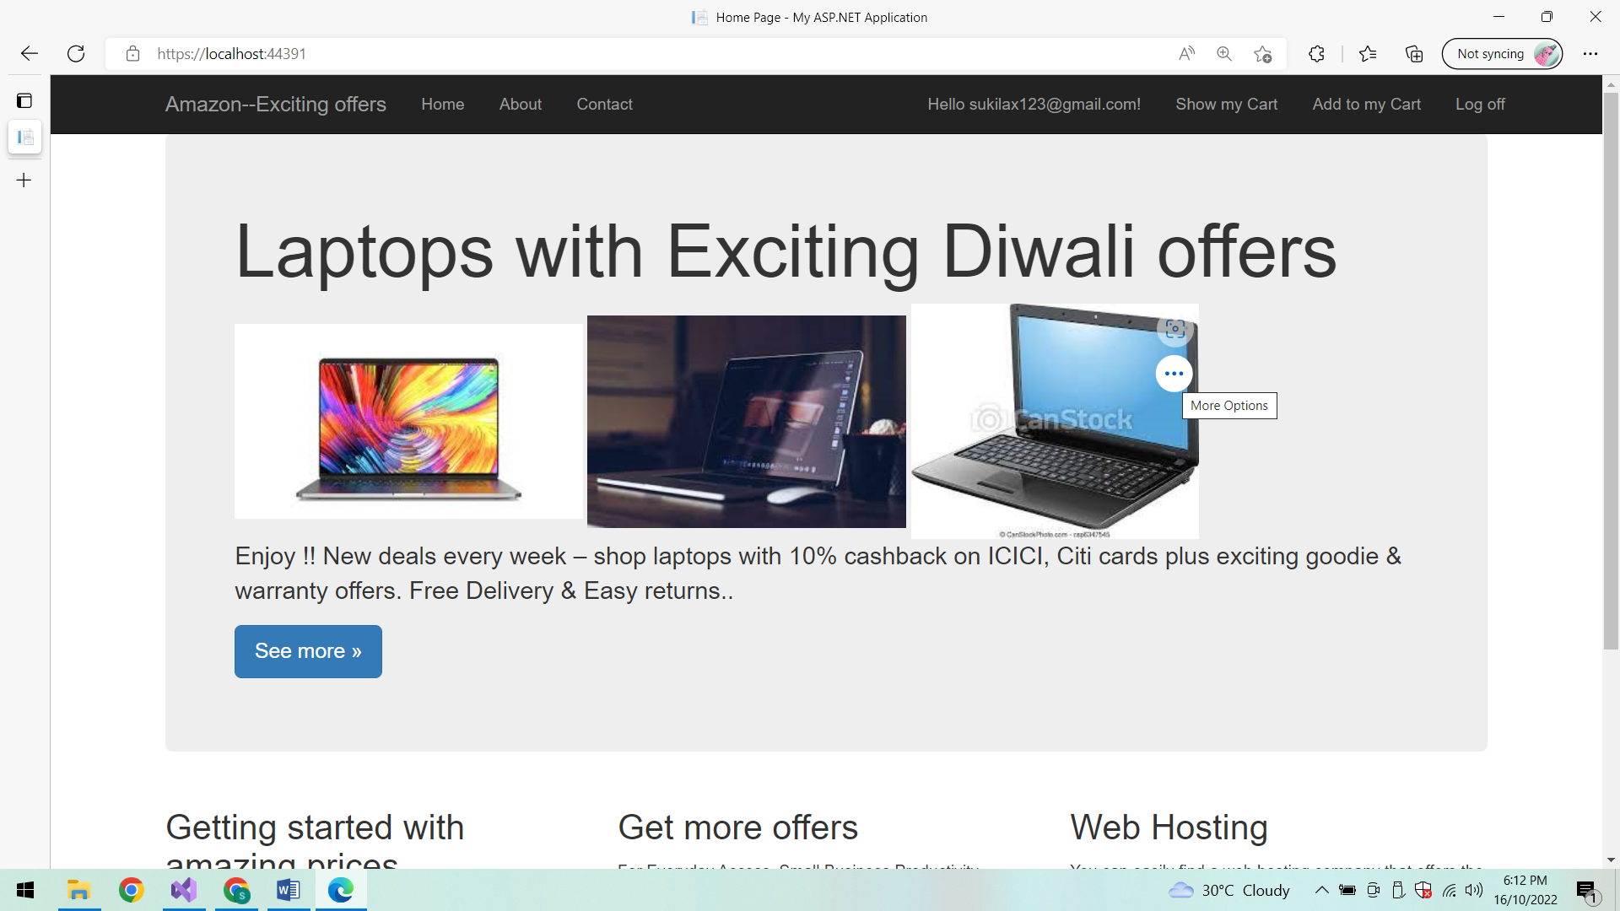

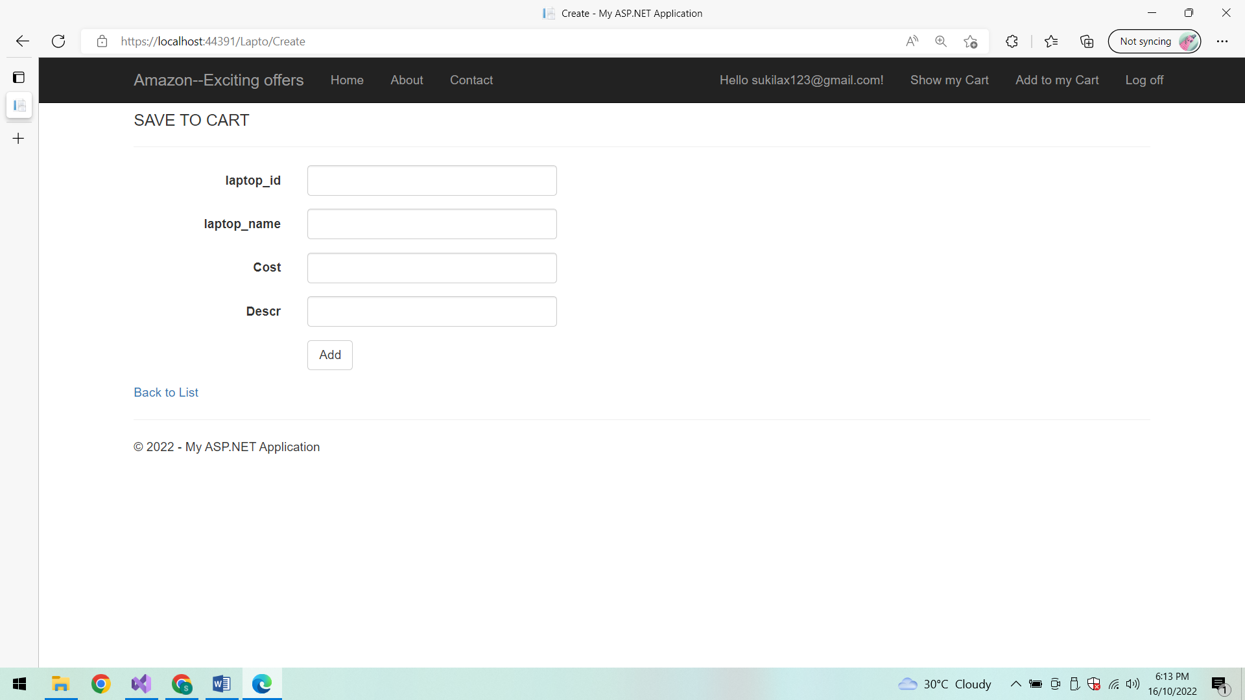

**Save to My cart:**

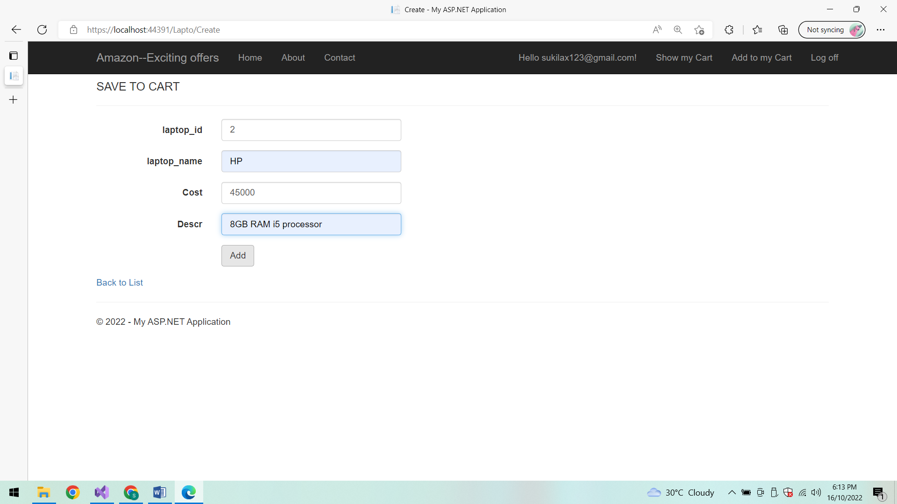

**After Adding the item to MyCart:**

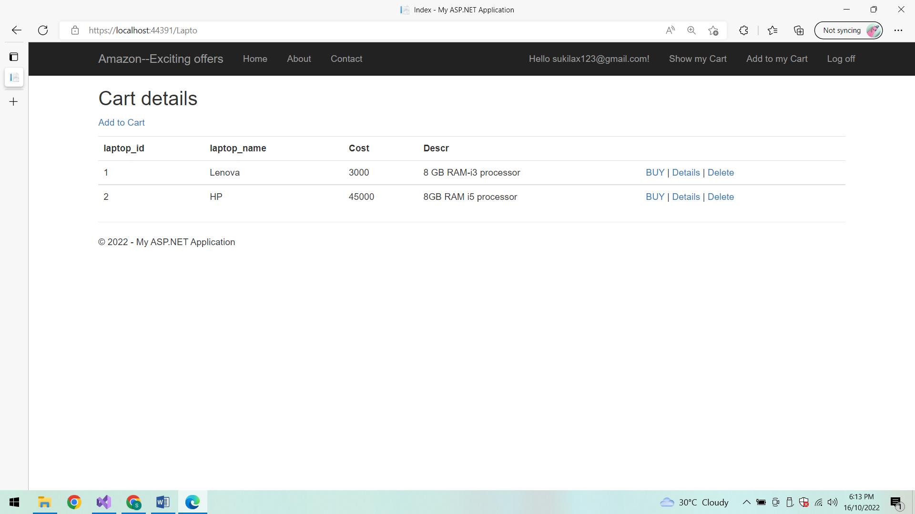

**Detail of the product:**

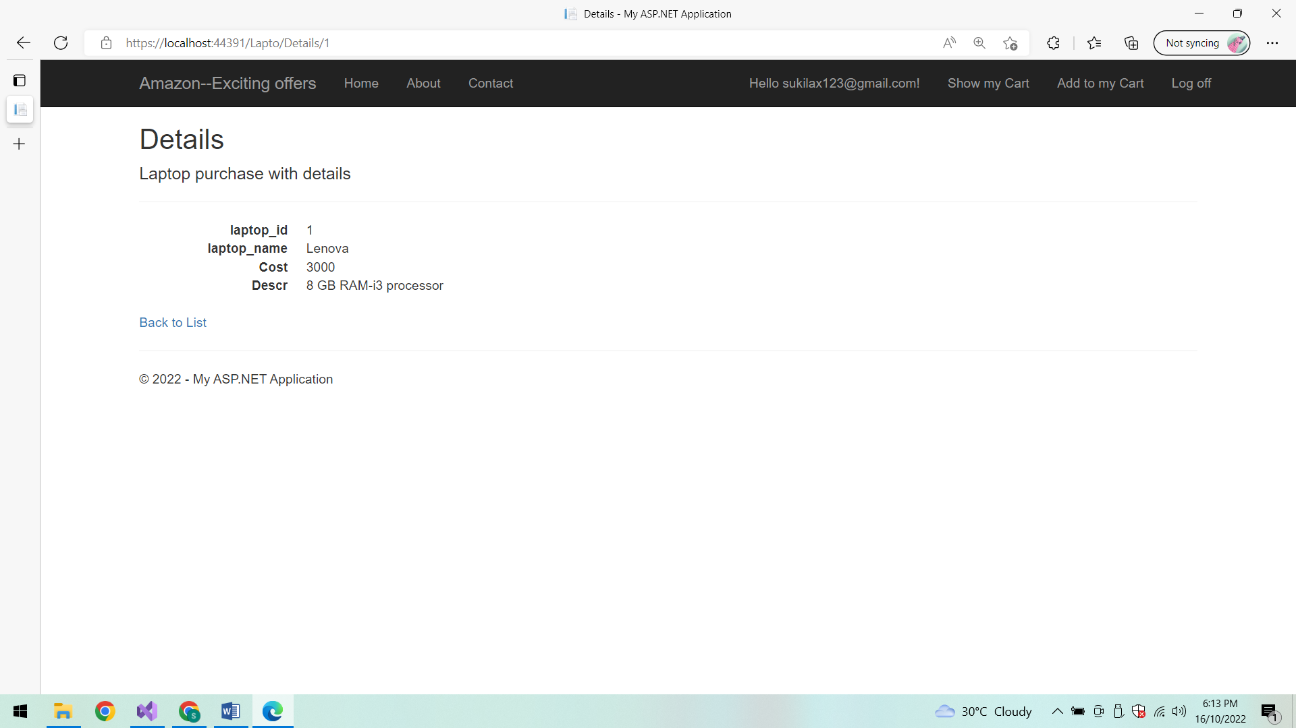

**To Buy the product:**

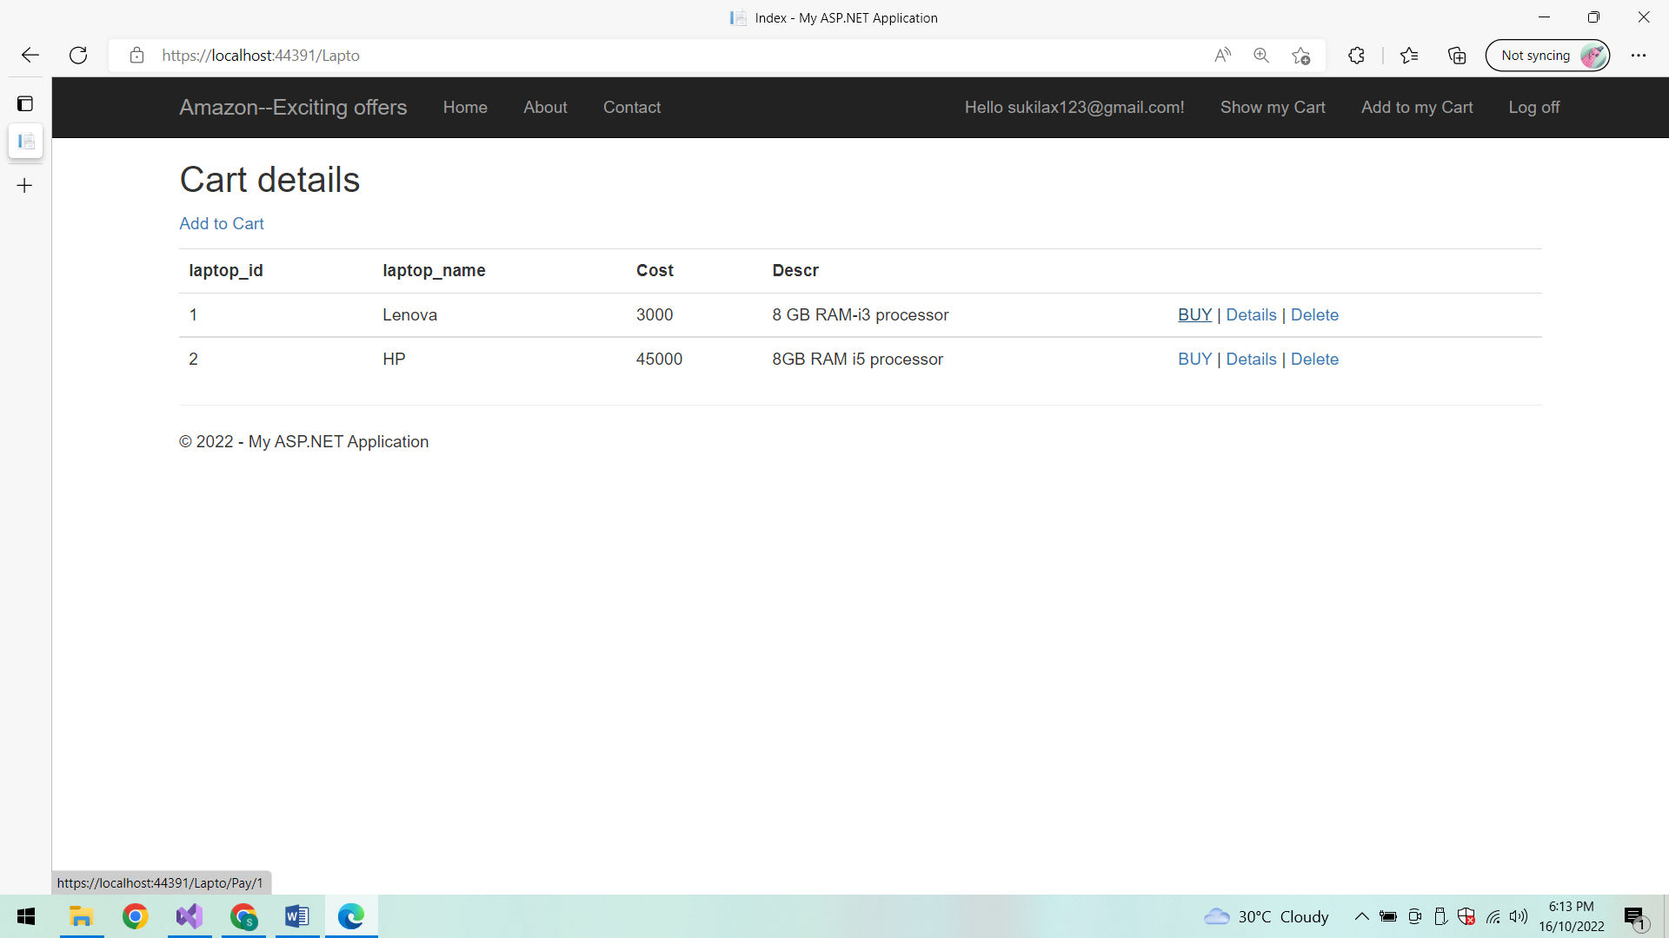

**To purchase Card details and payment site:**

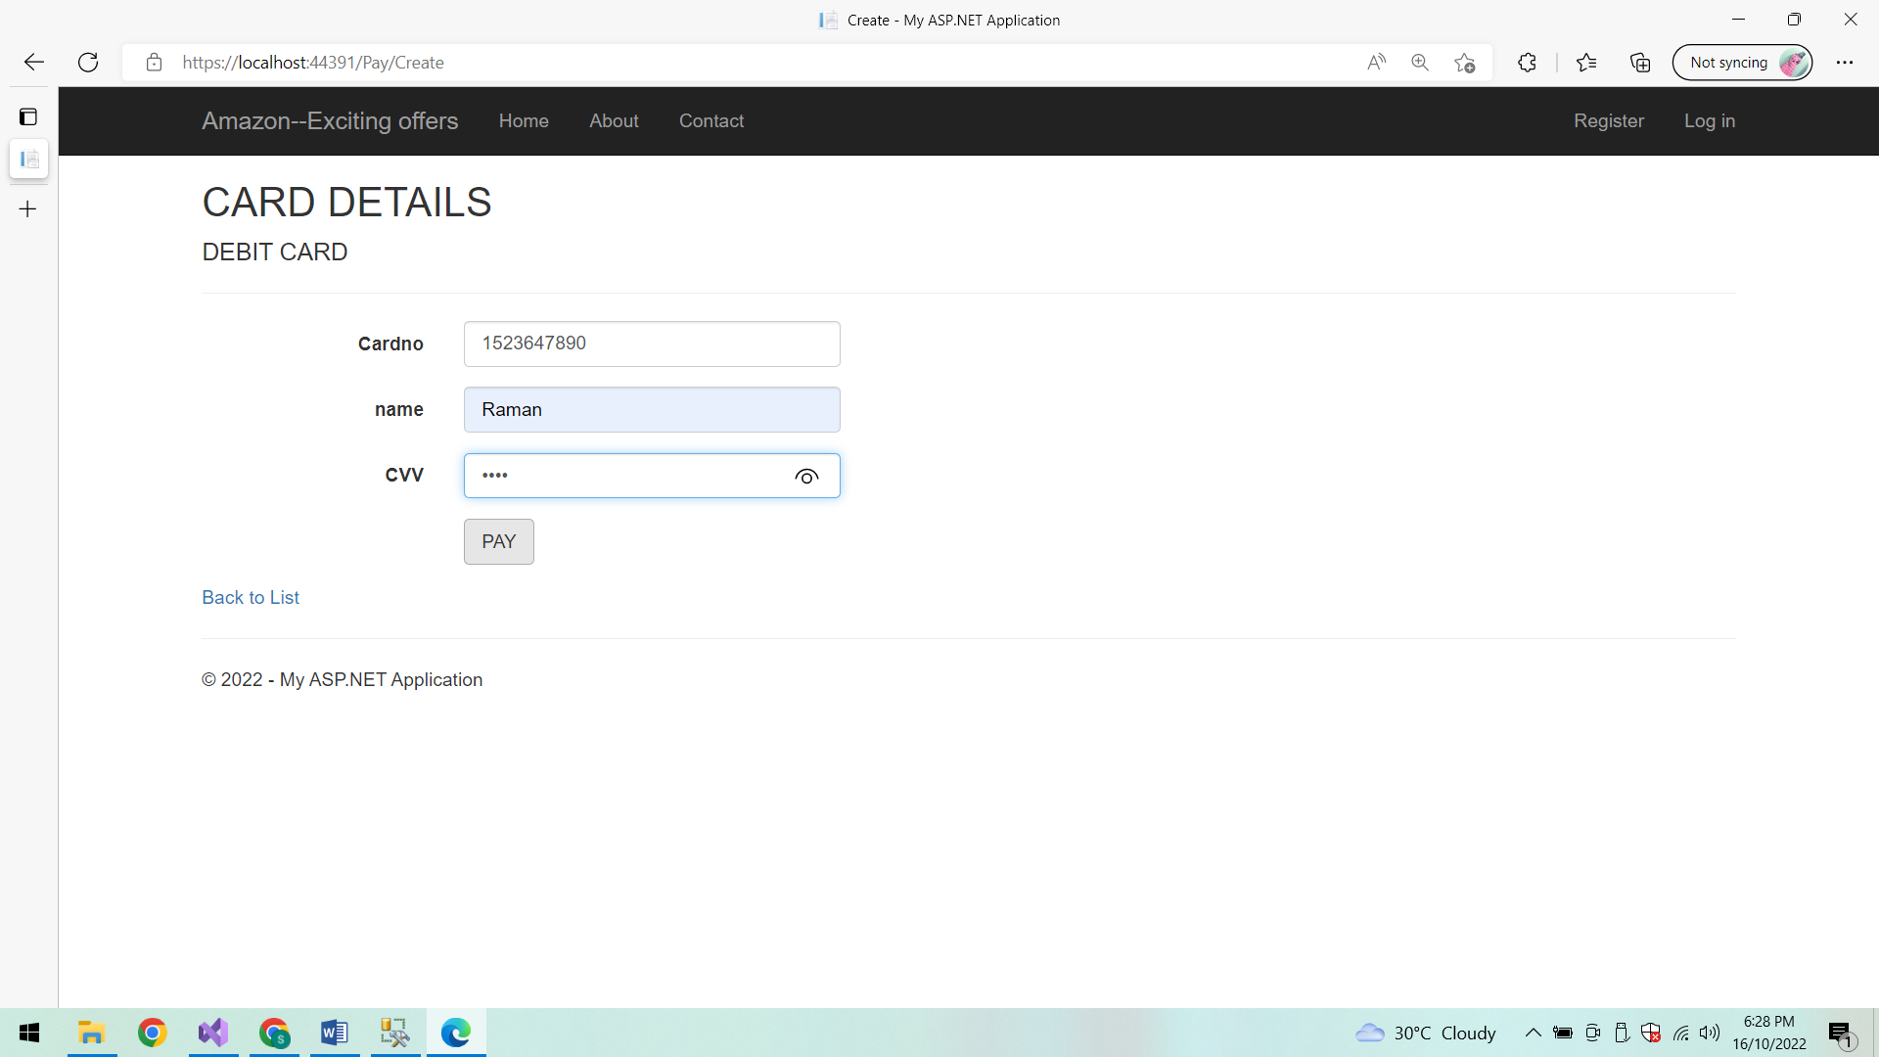

**After Successful Payment:**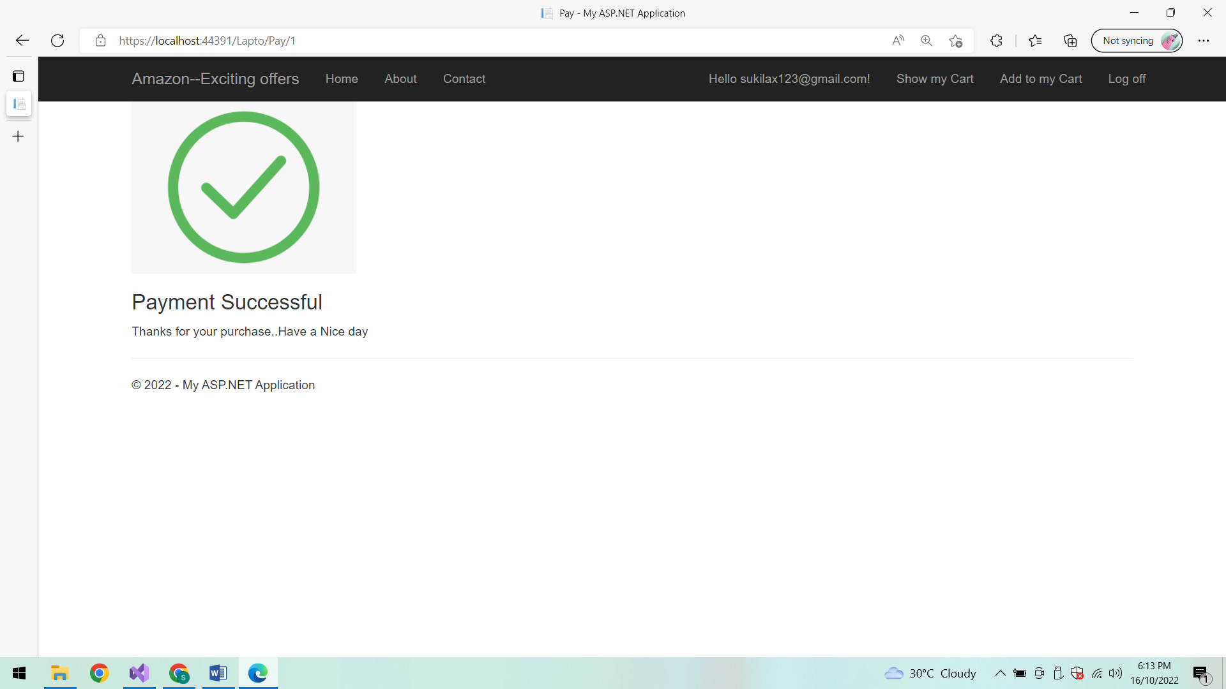

**Delete product:**

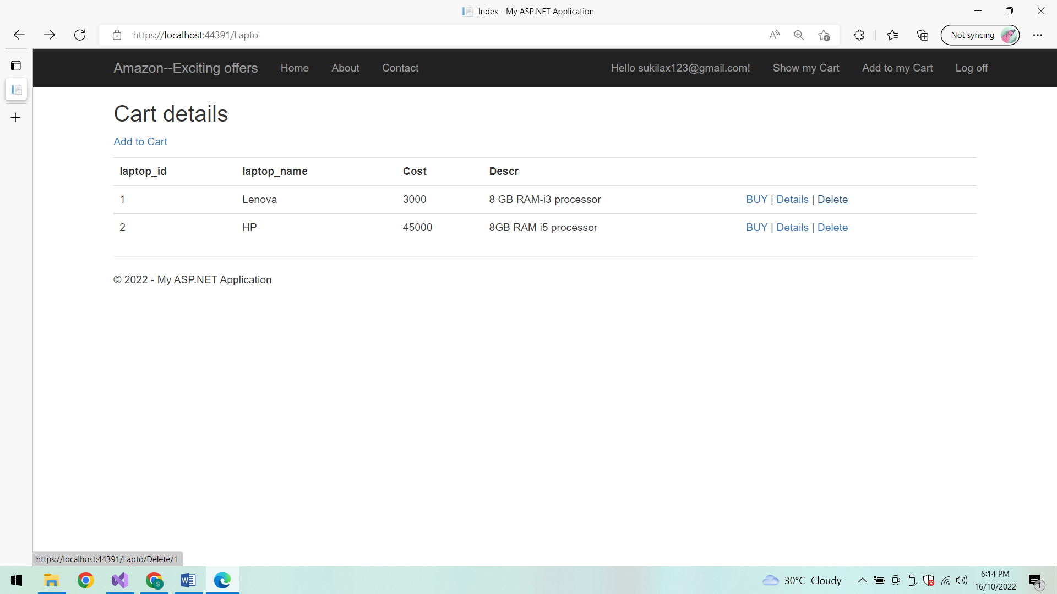

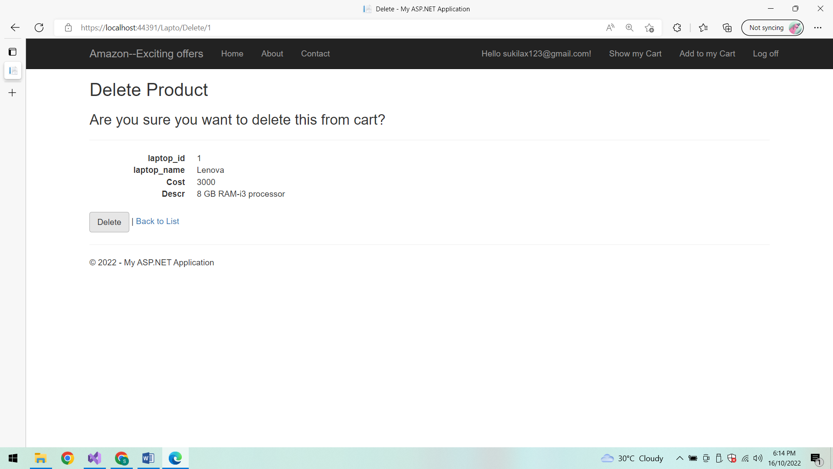

**After Deletion:**

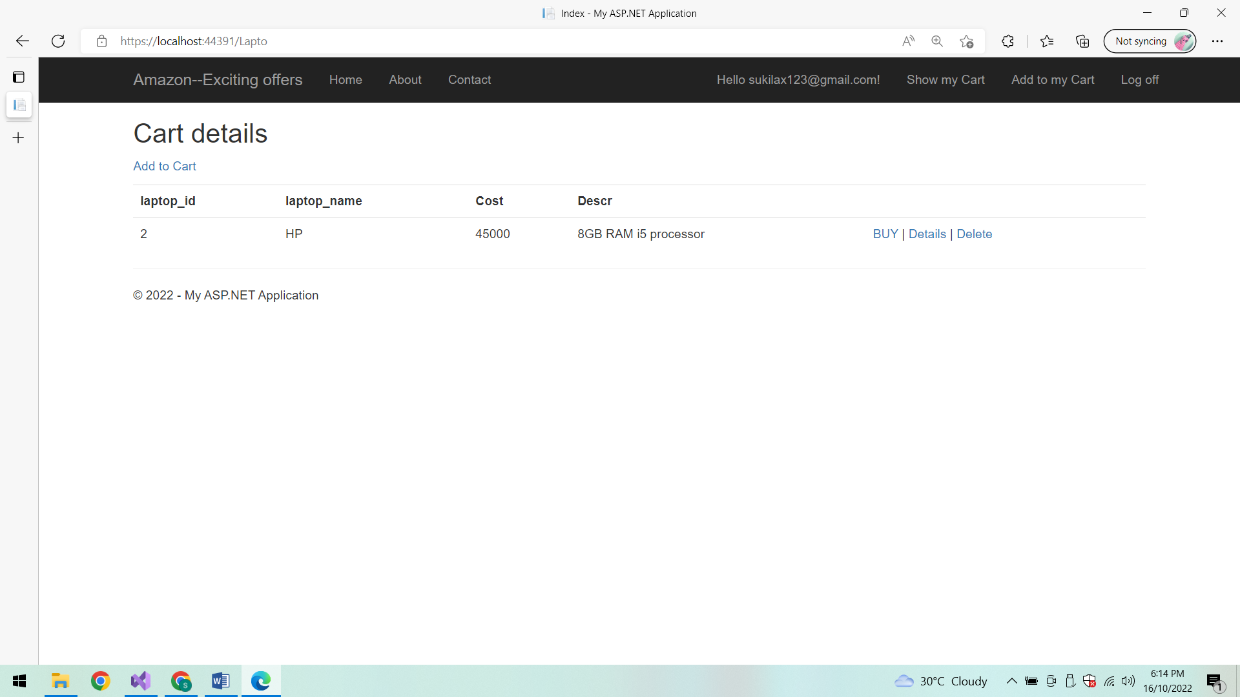

**Log off:**

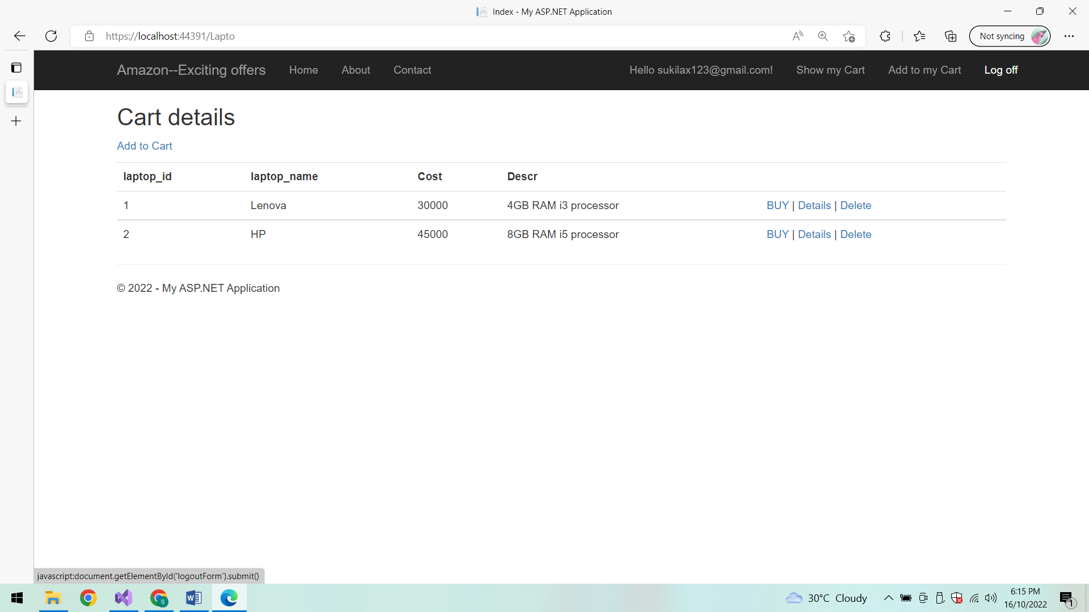

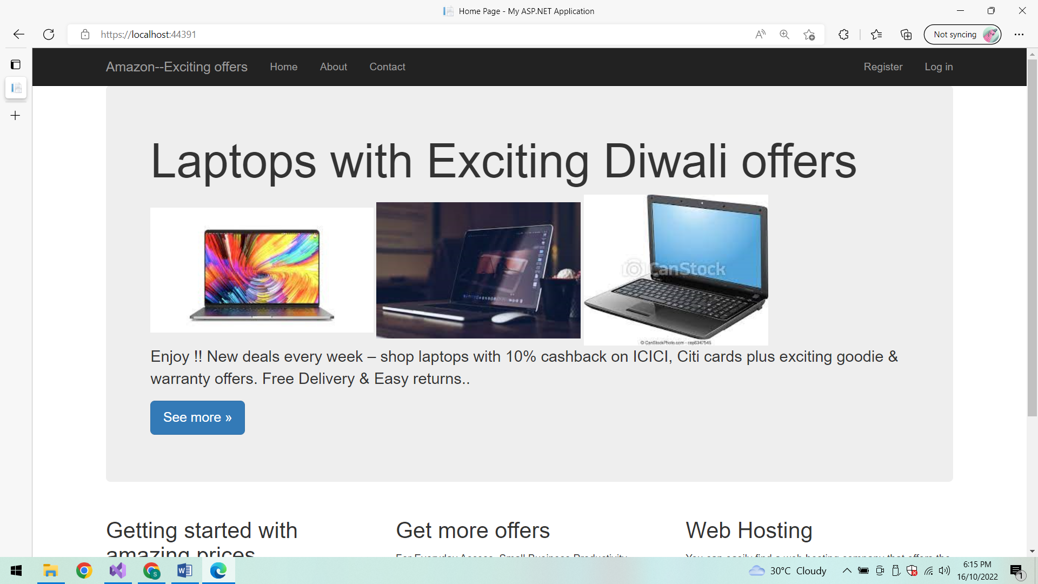

**Registration validations:**

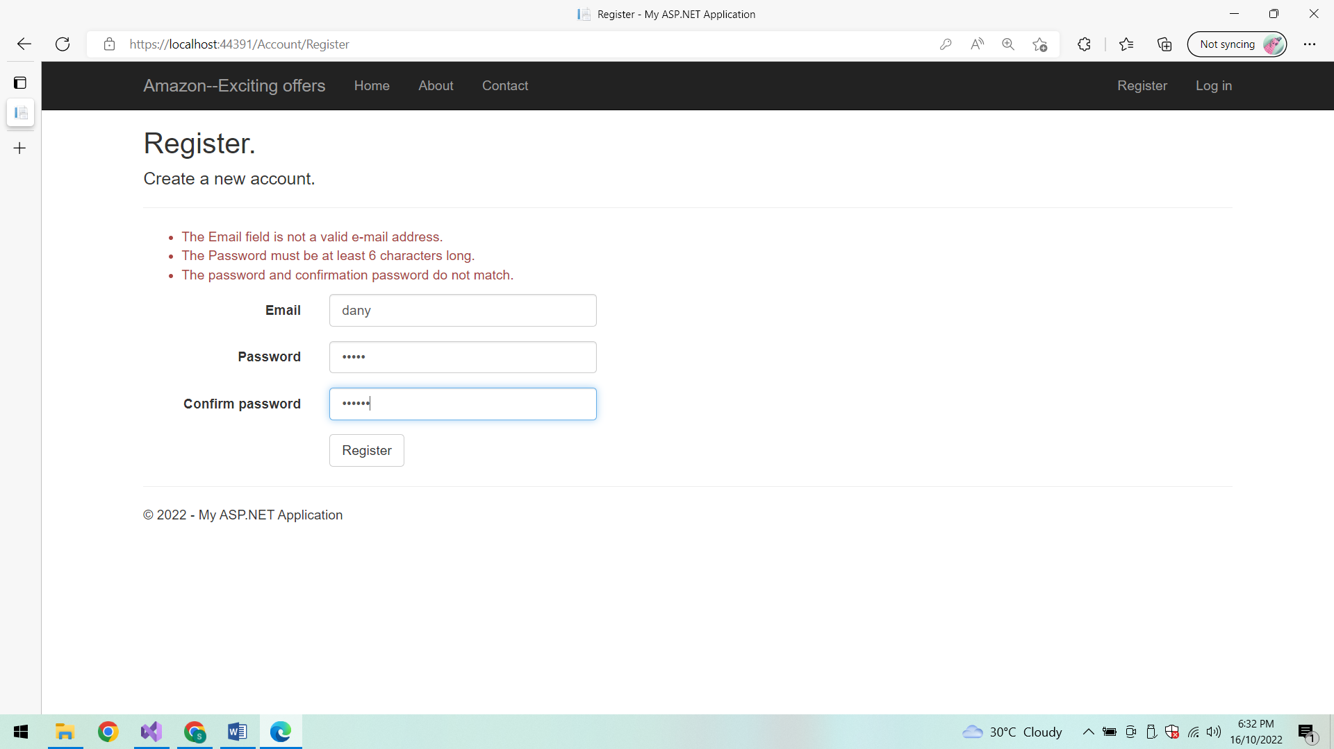

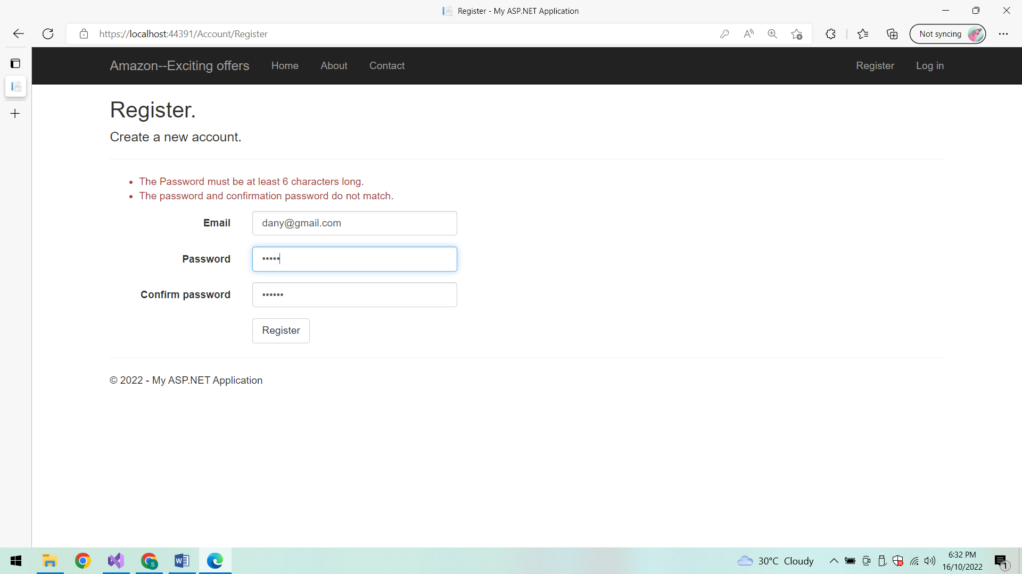

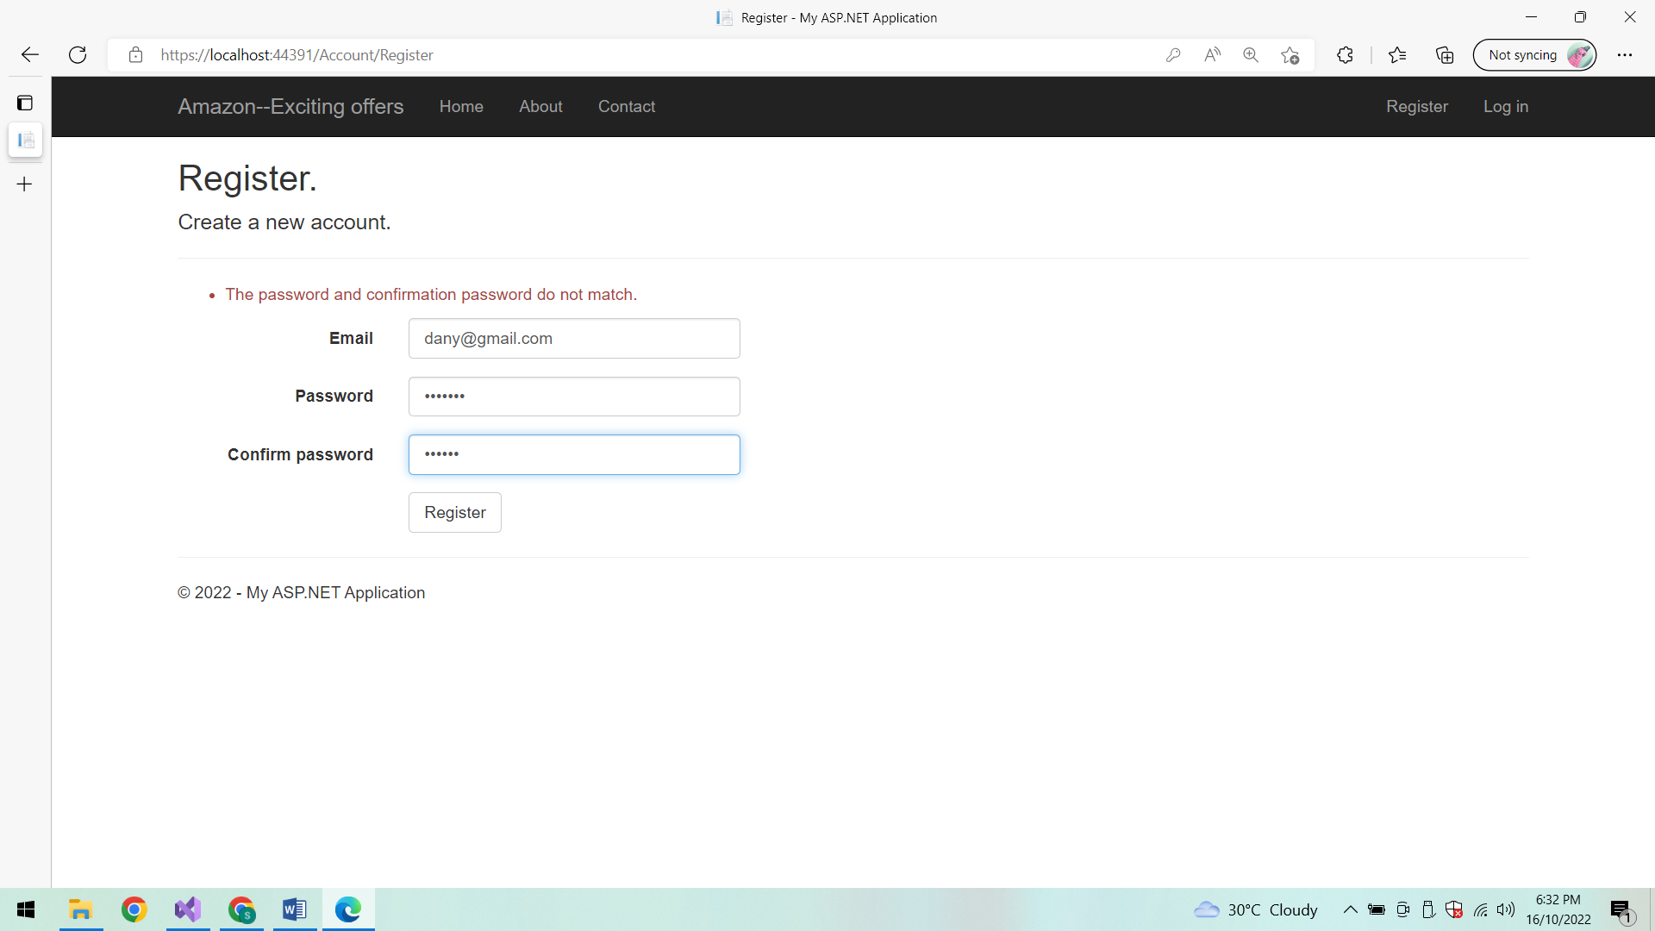

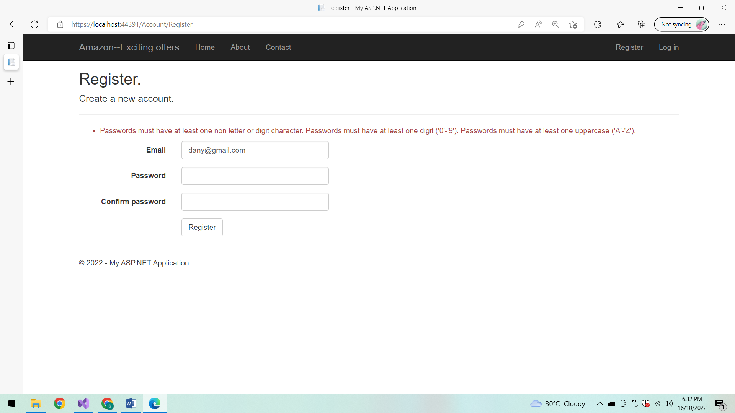

**Login Validations:**

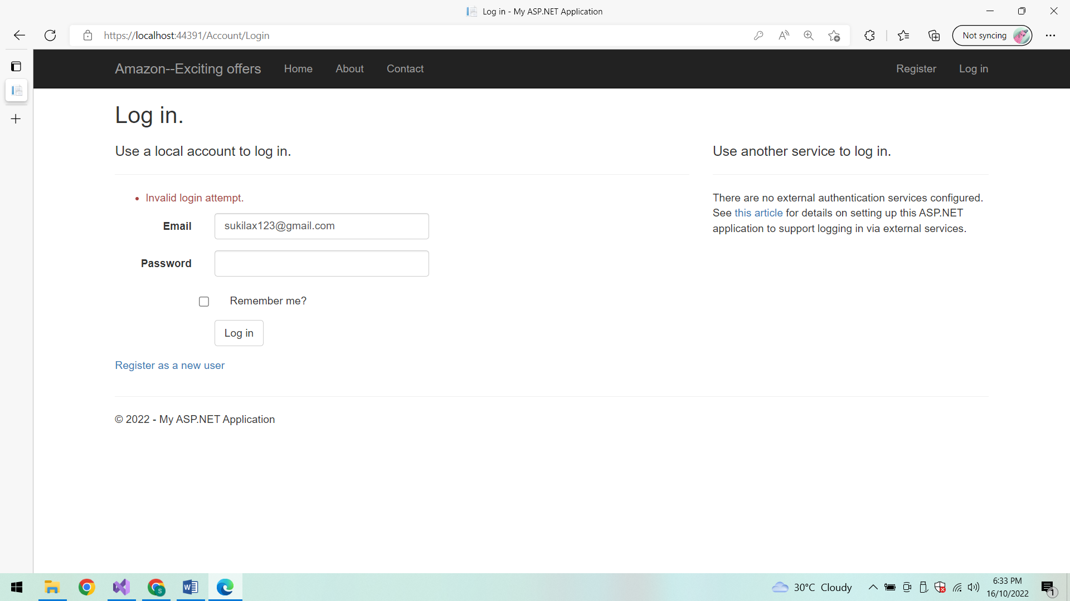

**Invalid Login attempt:**

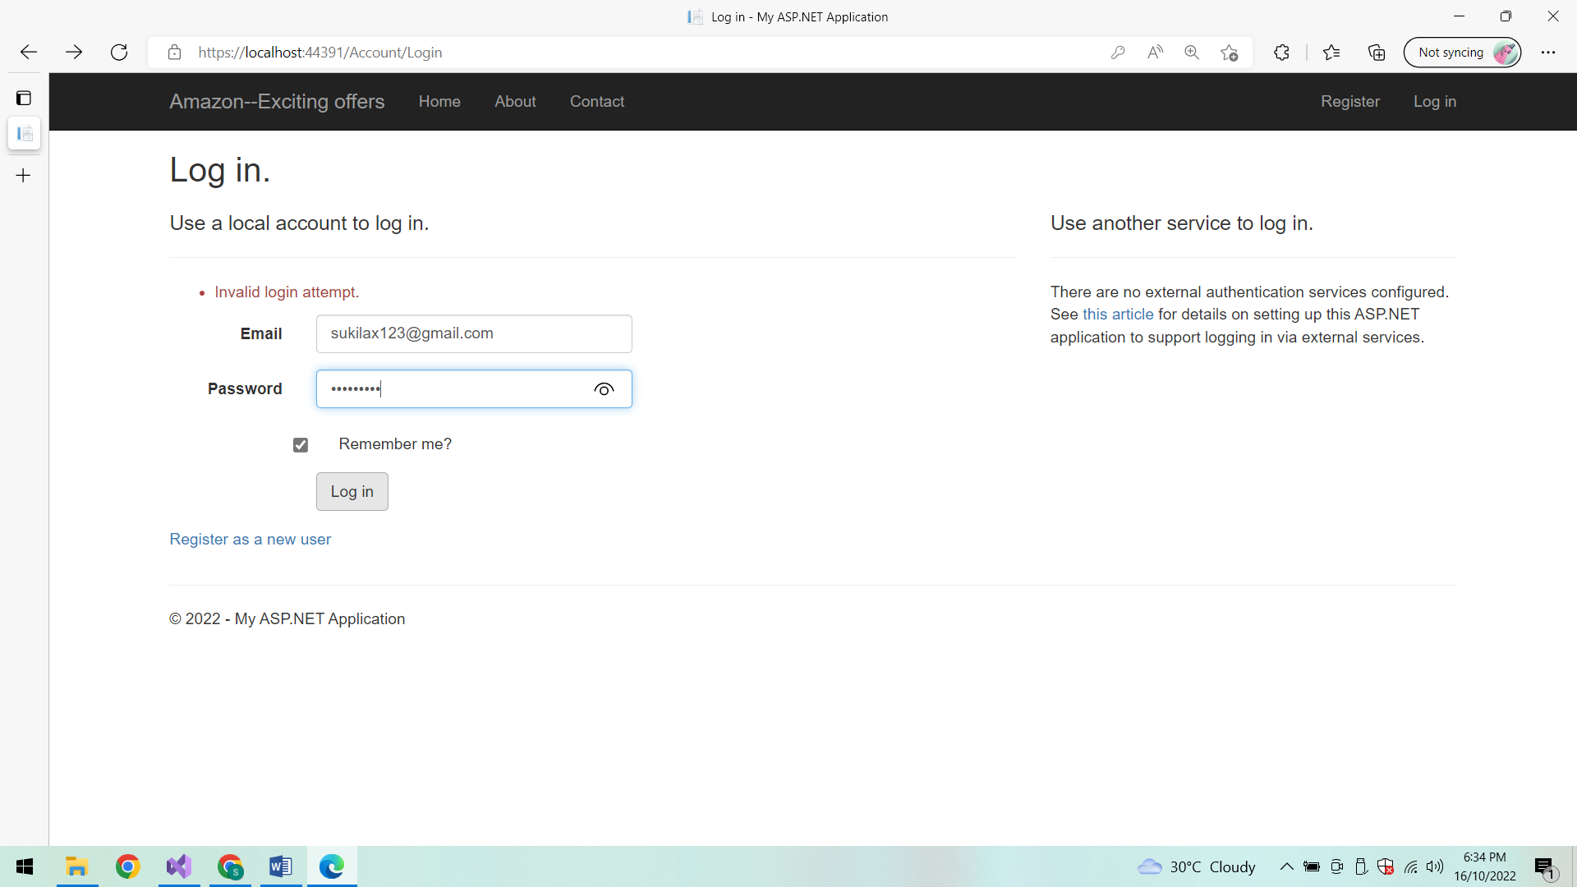

**About:**

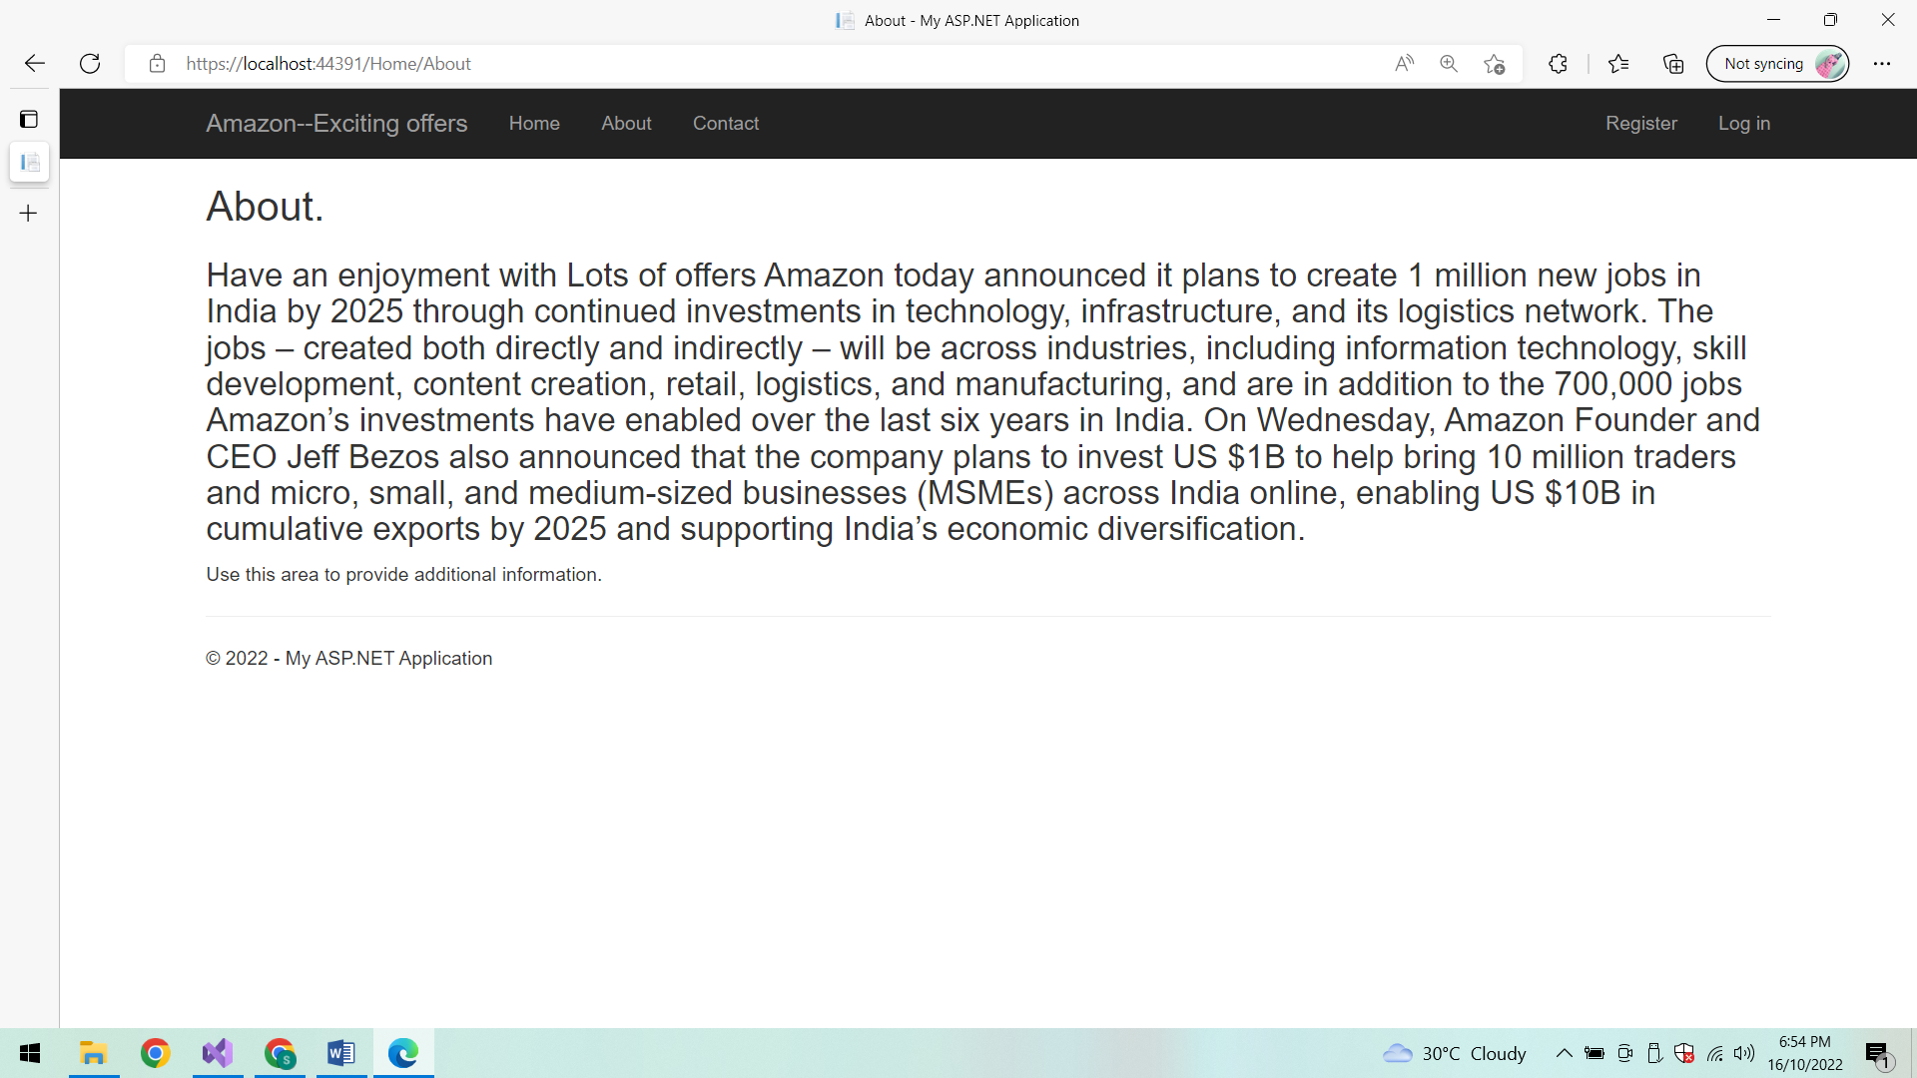

**Contact:**

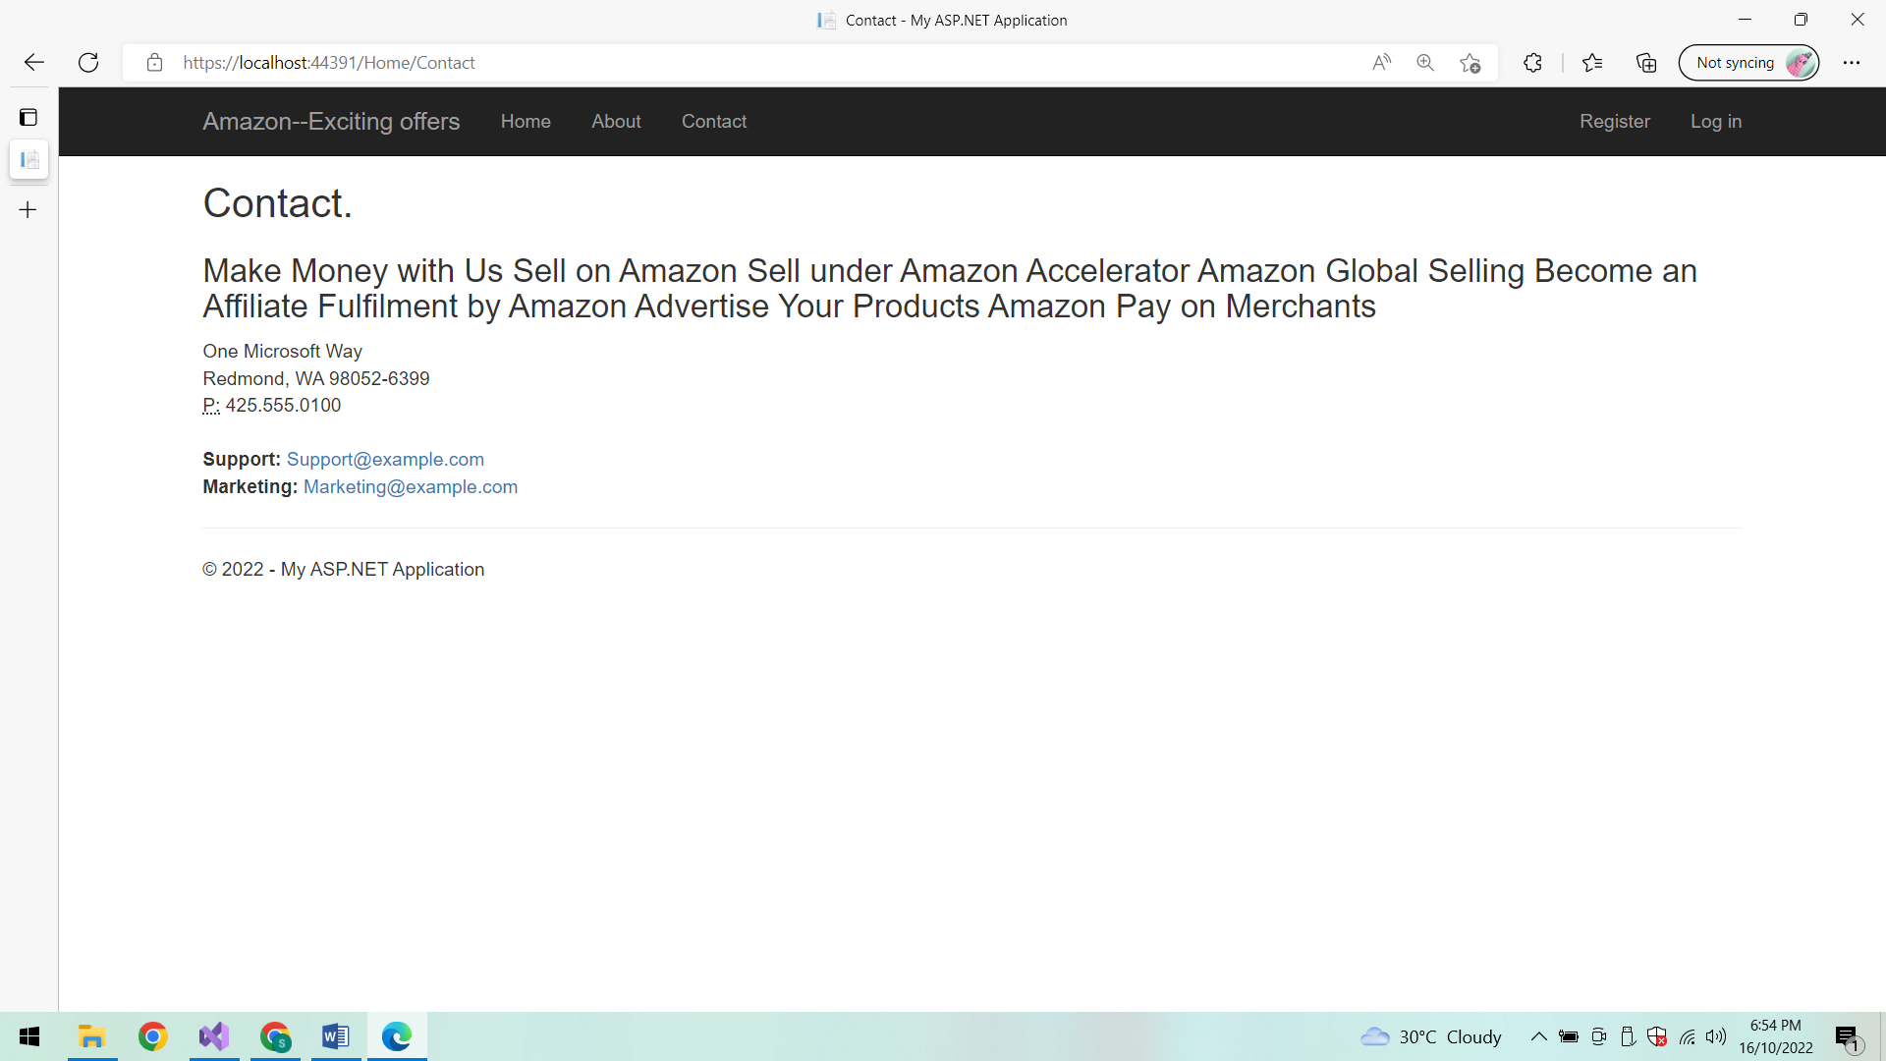

**Conclusion:**

Thus the application is developed successfully.